Getting Started with Framework for Risk Analysis in Multimedia Environmental Systems (FRAMES) 1.3

M. A. Eslinger
G. M. Gelston

DRAFT May 20, 2002

Prepared for the U. S. Department of Energy

Pacific Northwest National Laboratory
Richland, Washington 993

Contents

1.0 Introduction 1

2.0 How to create a new scenario setting in Framework for Risk Analysis in Multimedia Environmental Systems 1.3 3

2.1 Drag and Drop Icons 4
2.2 Icon Identification 6
2.3 Connecting Icons 6
2.4 Selecting a Module 8
2.5 Choosing Constituents 9

3.0 Modules 11

3.1 Source Term Module 11
3.1a Adding References 13
3.1b Running Modules 14
3.2 First Vadose Zone Module 15
3.3 Second Vadose Zone Module 15
3.4 Saturated Zone Module 15
3.5 Surface Water Module 15
3.6 Atmospheric Transport Module 15
3.7 Exposure Pathways Module 15
3.8 Receptor Intake Module 16
3.9 Human Health Impacts Module 16
3.10 Selecting a Viewer 16
3.11 Customizing the workspace 16
3.12 Printing the Scenario 17

4.0 Appendix A.1

4.1 Constituent Database Module A.1
4.2 Source Term Module A.1
4.3 Vadose Zone Transport Module A.4
4.4 Vadose Zone Transport Module A.5
4.5 Ground Water Transport Module A.6
4.6 Atmospheric Transport Module A.7
4.7 Surface Water Transport Module A.8
4.8 Exposure Pathway Module A.9
4.9 Receptor Intake Module A.11
4.10 Human Health Impact Module A.12
4.11 FRAMES File Extensions A.14

Figures

1.1 Example Scenario Picture 2
2.0.1 FRAMES 1.3 Desktop Shortcut 3
2.0.2 FRAMES Main Screen 3
2.1.1 Constituent icon 4
2.1.2 Source Term icon 4
2.1.3 Vadose Zone icon 4
2.1.4 Aquifer icon 4
2.1.5 Surface water icon 5
2.1.6 Air icon 5
2.1.7 Exposure pathways icon 5
2.1.8 Receptor intake icon 5
2.1.9 Health impacts icon 6
2.1.10 Completed icon selection 6
2.3.1 Constituent database linkages 7
2.3.2 Completed module linkages 7
2.3.3 Module linkages 8
2.4.1 Module options menu 8
2.4.2 Label options for modules 9
2.4.3 Red signal light 9
2.5.1 Module options menu 10
2.5.2 Selecting Constituents 10
2.5.3 File drop down menu 11
2.5.4 Green signal light 11
3.1.1 Labeling and selecting the Source Term Module 12
3.1.2 Constituent inventory worksheet 13
3.1.4 Adding references to User Input 13
3.1.5 Values referenced on the User Input screen 14
3.1.6 Automatically run all modules 14
3.1.7 The model runs in an MS-DOS screen then returns to FRAMES 14
3.11.1 Customize menu 16
3.11.2 Colors Customize menu 17

1.0 Introduction

Every contaminated site has a story behind the scenes, containing explanations and descriptions of the location and exposure pathways. This is the story for the scenario used in Getting Started with FRAMES. The data used to fill in this example scenario is consistent with the story told below. Getting Started contains this example scenario designed to help familiarize you with the FRAMES software platform. After completing this test scenario, you should be able to start with your own site and run a scenario. Step by step instructions are included throughout Getting Started. Read this scenario then follow the instructions to create your own scenario.

Beginning in November of 1995, a manufacturing company deposited its radioactive and nonradioactive by-products onto the ground in a 10’ x 10’ area. The deposit is not covered. The waste represents the only waste unit at the facility. The site is near the Green Stone River. The Site was ordered closed by the U.S. Environmental Protection Agency. Constituents of concern include antimony, strontium 90, and trichloroethylene.

While the site was still active, mechanical traffic and poor management practices resulted in a considerable amount of wind-blown particulate matter to be transported from the site. Over the years, the residential soil of the nearby town of Fieldview became contaminated. Residential soil samples have been taken.

Samples have also been taken of the site sediments. The river is used for drinking water, irrigation and stock/feed water for livestock. Also, fishing and swimming occur on this stretch of the river. The local population consumes aquatic life from the river, and locally grown crops and livestock. There is an intake structure downstream where the contaminants enter the river; this structure is used to supply feed/stock water and irrigation water to two nearby agricultural farms: one in Bend County and one in Blue County. Inorganics were not sampled for in the river, but organics were sampled for. Measured concentrations of carbon tetrachloride have been detected five miles downstream from the facility.

Contaminants have been measured in the local groundwater in the local groundwater system. Several private and municipal wells use the groundwater from the same aquifer; however, most of the wells are located significantly up gradient from the landfill, are uncontaminated, and do not change the groundwater flow system when pumping. One pumping well though is located down gradient of the waste site, and is contaminated with low levels of constituents. This well is currently being used as a municipal drinking water well for the town of Fieldview. Besides contaminating the pumping well, the contaminated groundwater also recharges to the Green Stone River.

On hot days, local residents have complained of pungent odors, suggesting volatilization of chemicals; three of the chemicals of concern can volatilize. The area is heavily agricultural and dry deposition of contaminants on plants and consumption by humans is possible. It is also possible for plants to uptake residual chemicals from the soil. All records and information pertaining to the site, including maps, photographs, and sampling result summaries are stored at the County Health Department in Fieldview.

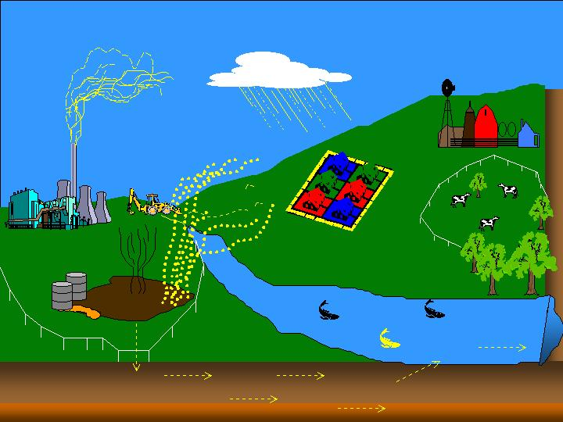
Figure 1.1 Example Scenario Picture
2.0 How to create a new scenario setting in Framework for Risk Analysis in Multimedia Environmental Systems 1.3

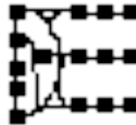
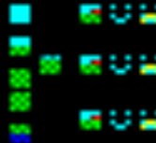
After installing the FRAMES software on your computer, a shortcut labeled ‘FRAMES 1.3’ will automatically be placed on your desktop. Open FRAMES by double clicking on the shortcut (Figure 2.0.1).
Figure 2.0.1 FRAMES 1.3 desktop shortcut
Or FRAMES can be opened using a file browser such as Windows Explorer. To open FRAMES through the browser, go to the folder in which FRAMES was installed (usually C:/FRAMES) and select fui.exe. After opening the software, notice the parts of FRAMES visible on your desktop. The blank main screen, the toolbar located on the left hand side, and the menu at the top of the screen. (Figure 2.0.2).

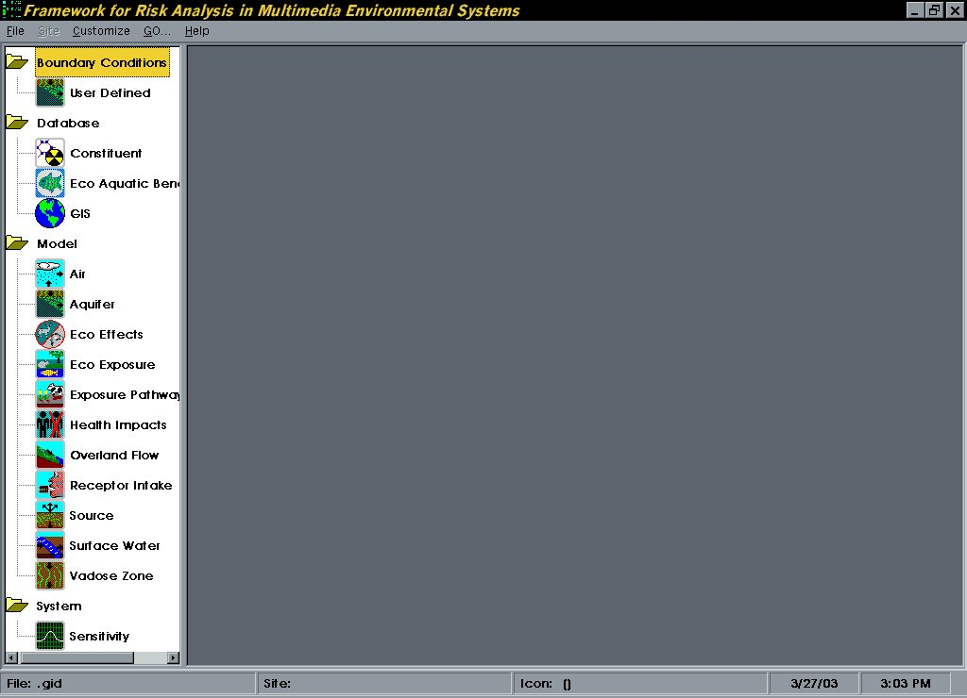
Figure 2.0.2 FRAMES Main Screen

To begin a new case, select File/ New. The Global Input Data New screen will open. Select the location to save the new gid file and select ‘Open.’ In this scenario the file name will be Case01.gid. (NOTE: File name should be longer than 8 characters with no spaces or special characters). The extension is GID (Global Input Data file). The Create New Site screen will ask for a site name. Enter a site name and select ‘Ok.’ The file name and path also appears in the status bar of the main FRAMES screen.

The first step in building a scenario is to gather all the necessary icons. Each icon located on the FRAMES toolbar represents a module to be linked together to model the site. Different icons may appear in the toolbar based on the modules included in the version of FRAMES installed on your computer. The main screen is a Site Conceptualization (SC) and shows the flow of contamination across the site being modeled through the linked icons. The SC defines the "real world" problem in a simplified way to conduct analysis. The problem is completely defined through the SC including release scenarios, source characteristics, release mechanisms, transport pathways, exposure routes, risk end points and risk metrics.

2.1 Drag and Drop Icons

To insert icons on the main screen, double-click on the icon located on the toolbar. The icon will appear on the main screen. Move the icon from where it was inserted by clicking on the icon and dragging to the desired place. Icons are grouped under folders in the toolbar by type (i.e., Boundary Conditions, Database, Model, and System), then alphabetized. To remove an icon from the main screen, click on the icon to select, then right click and choose ‘delete.’

This document walks you through the steps of creating the example scenario. The first icon to be inserted is the Constituent Database icon. Only one of these icons (black and yellow), needs to be inserted for multiple constituents to be selected (Figure 2.1.1). The Constituent Database icon
appears on the main screen with the label con1.

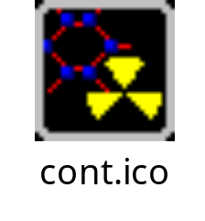
Figure 2.1.1 Constituent icon

Next insert the Source icon. This icon has three arrows coming out of the green-sprinkled ground that point to the sky and one arrow pointing to the bottom (Figure 2.1.2).

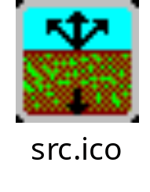
Figure 2.1.2 Source icon

The next icon to be inserted is the brown one with thin green lines called a Vadose Zone Module. You will insert two of these; one for each layer of soil in the scenario (Figure 2.1.3). The example scenario has two layers, however your scenario may have a varying number of soil layers depending on the site characteristics.
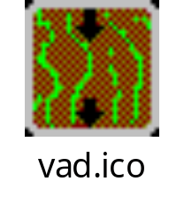
Figure 2.1.3 Vadose Zone icon

Insert the Aquifer Module also known as the Ground Water Module (Figure 2.1.4).
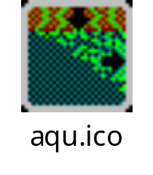
Figure 2.1.4 Aquifer icon

Now insert the icon depicting a river. This is the Surface Water Module icon (Figure 2.1.5).
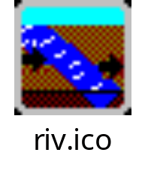
Figure 2.1.5 Surface water icon

Insert the Air icon, also known as the Atmospheric Transport Module that has the rain cloud (Figure 2.1.6).
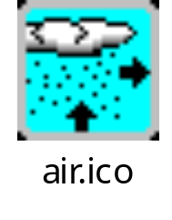
Figure 2.1.6 Air icon

The Exposure Pathways Module is the next icon to be inserted. This one has a cow and corn (Figure 2.1.7).
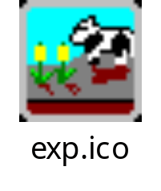
Figure 2.1.7 Exposure pathways icon

Next insert the Receptor Intake Module icon resembling the human face eating a hamburger. (Figure 2.1.8)
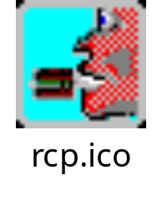
Figure 2.1.8 Receptor intake icon

The last icon to be inserted for this example scenario can be identified because there are two people shown and one of them is crossed off with a red X (Figure 2.1.9). This icon is the (Human) Health Impacts Module.
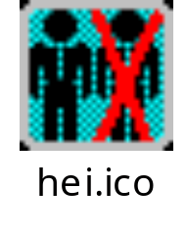
Figure 2.1.9 Health impacts icon

Now we have all the icons to be used on the screen for this example scenario. Arrange the icons so that they appear similar to Figure 2.1.10.

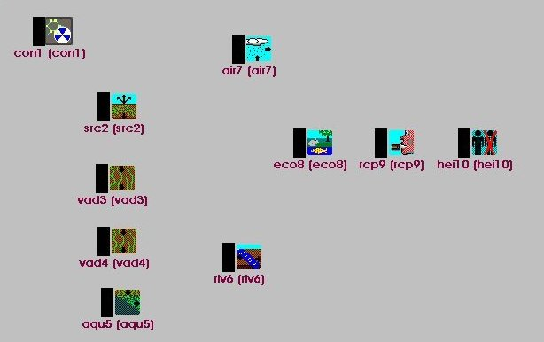
Figure 2.1.10 Completed icon selection

2.2 Icon Identification

When the icons are placed on the screen, a computer-generated label is automatically added. The label is based on an abbreviation for the type of module and a number for the order in which the icons were placed on the main screen. These labels can be customized when the module is selected. The user can display both the computer-generated name and the custom name by clicking on 'Customize' located on menu at the top of the main FRAMES screen and selecting ‘Show Object Id’. For this example scenario, the individual icons will be referred to by the computer-generated label.

2.3 Connecting icons

Link icons to simulate the flow of contamination by holding down the shift key, left-clicking on the icon, and dragging the mouse to the next icon. Remove the link in the same manner by holding down the shift key and dragging the mouse between icons. Any number and direction of connections is permitted between icons; however, certain modules may limit the connections. Different colored lines and arrows are used for the database, system, and module linkages for visual clarity. The status bar on the bottom of the FRAMES screen shows which icon is currently selected.

The order of connections for this scenario is as follows. The first icon Constituents (con1) is the database and needs to be connected to each of the other icons on the main screen. (Figure 2.3.1)

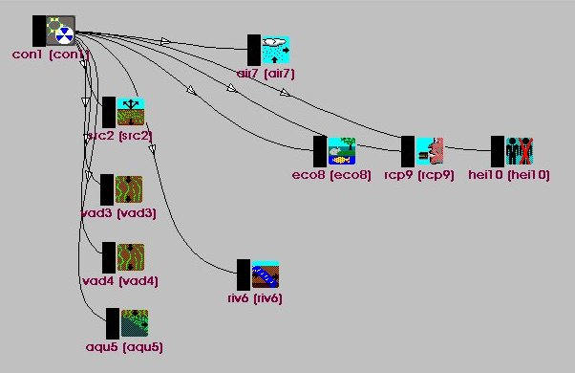
Every icon except (con1) should be connected so that the arrow on the link shows the direction of the flow of contamination. So (src2) should flow to two separate icons: one connection to (vad3) and the other line connected to (air7). (air7) should have one connection to (exp8). (vad3) should have a line connected to (vad4), and (vad4) should be connected to (aqu5). (aqu5) should be connected with two lines, one to (riv6) and the other to (exp8). (riv6) should have a line connected to (exp8). (exp8) should have a line connected to (rcp9). (rcp9) should be connected to (hei10). When they are all connected, the screen should resemble Figure 2.3.2.
Figure 2.3.1 Contaminant Database Linkages
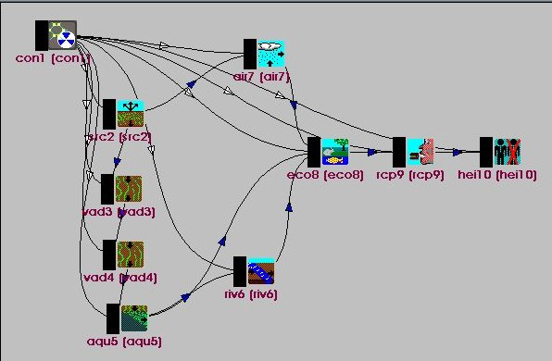
Figure 2.3.2 Completed Module Linkages

If the connections on the screen do not look like Figure 2.3.2, retrace the steps outlined. The connections between the modules without visible contaminant database connections are shown in Figure 2.3.3.

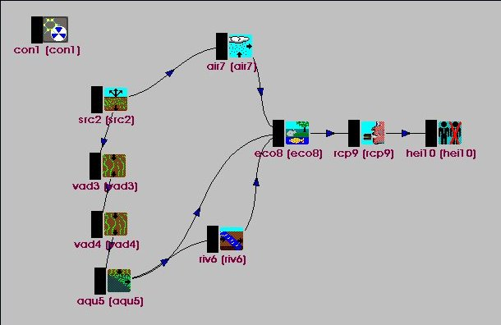
Figure 2.3.3 Module Linkages

Linkages may be added or removed at any point in the scenario, however changing a linkage may affect the selected module. When deleting a linked icon from the screen, the attached linkages will automatically be deleted also and do not need to be deleted separately.

2.4 Selecting a Module

Follow the same steps for selecting a module for each icon. First right click on the Constituent Database icon (con1). The pop-up menu has different options listed, some are bold and some are gray. (Figure 2.4.1) Bold options signal steps that can be selected, so click on ‘General Info.’
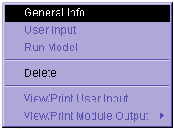
The Object General Information screen will open (Figure 2.4. 2).
Figure 2.4.1 Module options menu

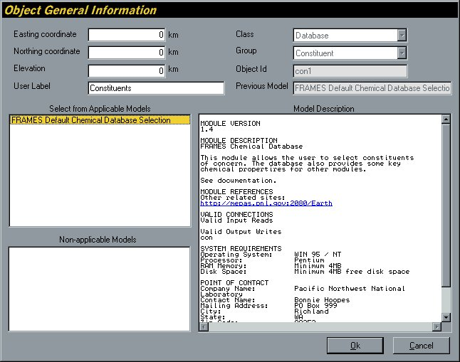
The Object General Information screen contains several parts. The heading section should be left at the default, except for the Label section. A user-defined label can be entered, or the default used. In this scenario, enter the label Contaminants. There is only one Applicable Model and no Non-applicable models for the Contaminant Database, however many modules have multiple applicable and non-applicable models. Select a Model and the Model Description will appear on the right side of the screen. Select the Applicable Model, FRAMES Default Chemical Database Selection and click 'Ok'. FRAMES returns to the main screen and the user-defined label appears under the icon. The black side bar on the icon is a signal light, which changes color every time a step is completed (Figure 2.4.3). After naming the icon and selecting the applicable model, the light should be Red.
Figure 2.4.2 Label options for modules

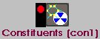

2.5 Choosing Constituents
Figure 2.4.3 Red signal light

The User Input section is the next part to be completed. This is where the user-defined data is entered. Right click the Constituent icon and the box shown in Figure 2.5.1 will open. This time the menu will show 'User Input' and ‘General Info’ in bold.
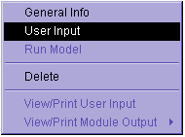
Figure 2.5.1 Module Options menu
Select 'User Input' and a new screen will appear titled Constituent Selection (Figure 2.5.2).
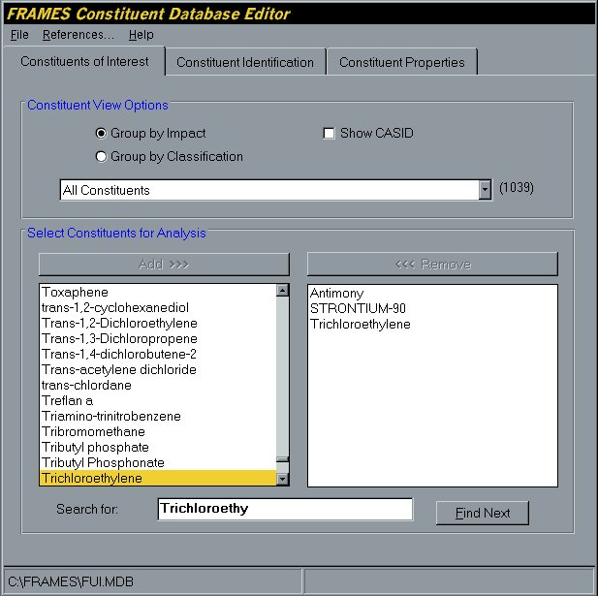
Figure 2.5.2 Selecting Constituents

Enter the scenario-specific constituents on the FRAMES Constituent Database Editor. There are several tabs across the top of the screen, for this scenario (and most scenarios) use the defaults provided in the Constituent Identification and Constituent Properties sections. On this tab, there are several different ways to group constituents to narrow the selection and assist in finding the desired constituent. Clicking on any of the options under Constituent View Options will change the view.

Several ways are also provided to select the constituent. Scroll down through the list on the left side of the screen using the arrow buttons, or type in all or part of the constituent in the Search box. The Search will automatically find the first listing of the constituent. Click Find Next until the specific constituent is found. For example when Strontium is entered in the Search box the first constituent in the alphabetical listing to be found is Strontium ion. Clicking Find Next jumps to the next use Strontium-85, clicking another time results in the one for this scenario, Strontium-90. Once the desired constituent is selected, click ‘Add,’ and the constituent will appear on the right side of the screen. An unlimited number of constituents can be added to the scenario in any order. They will be alphabetized in the box on the right side of the screen even if selected in a random order. To remove a constituent from the scenario, highlight the constituent on the right side of the screen and select ‘Remove.’
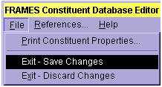
Figure 2.5.3 File drop down menu
The constituents for this example scenario are Antimony, Strontium-90, and Trichloroethylene. Once the constituents are selected, return to the main screen by selecting File and Exit-Save Changes from the drop down menu. Constituents can be added to and removed from the gid file at any point by following the steps outlined here. The signal light on the Constituent icon should change from red to green after constituents are selected and saved (Figure 2.5.4). Databases, unlike models, do not need the third option (Run Model) selected on the right-click pop up menu, so the yellow light never appears for the Constituent icon.
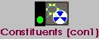
Figure 2.5.4 Green signal light

3.0 Modules

The modules work together to answer the following questions: what is the risk, who is at risk, when did the risk occur, why and how did the risk occur, and what are the uncertainties. Each module needs data input to run and produce a results file to answer these questions. For more information on what data is included in each module, press F1 at any time to view the help file specific to the module and parameter.

3.1 Source Module

The Source Module defines the release scenarios for the contamination. This includes the type of release (i.e., routine, accidental, etc.), a definition of the release (i.e., leaking drums, etc.), the potential release type (probabilistic or environmental), the probability of release, and the release fraction of waste. The Source characteristics are described including waste type, waste form, release site dimensions and physical characteristics.

Begin entering data in the Source Module by right clicking on (src2) and selecting ‘General Info’ from the pop up menu (Figure 2.4.1). The Object General Information screen will open (Figure 3.1.1). See Section 2.4 for a description of this screen. Enter the label Source, select the applicable model MEPAS 4.1 Computed Source Term Release Module and select ‘Ok.’

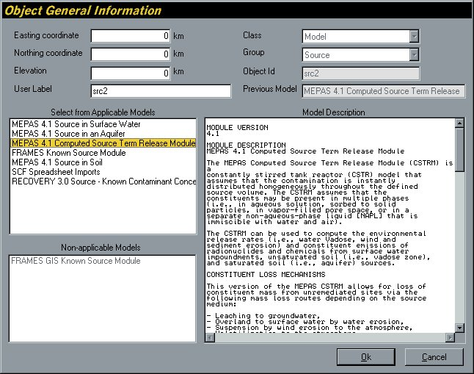

Figure 3.1.1 Labeling and selecting the Source Term Module

After selecting 'Ok' the main screen will appear and a red signal light will appear next to the source icon.

Right click again on the Source icon. Select ‘User Input’ from the pop up menu (Figure 2.5.1).

Wait for the User Input screen to open, then input the scenario specific data. (Appendix 4.2)

Input all the data into the module, then select ‘Save and Exit’ from the File menu. Returning to the FRAMES main screen may take some time depending on the speed of the operating system. No messages appear during the time that FRAMES is writing the output file. A large file may take a significant amount of time to process, but will not have a wait message. Wait for the program to finish running, then continue. An empty parameter entry shown by a red box can cause an error message after you click ‘Exit and Save.’ The error message will appear and should tell you which parameter is incorrect. The data must be entered before the scenario can proceed. Reenter the User Input section and confirm that all the parameters are green. Once all the necessary information is entered, the signal light attached to the icon will turn yellow. The yellow light indicates data was successfully input to the model.

The Constituent Inventory Quantity parameters found on the Constituent Properties tab show green for the parameter even when no data has been entered. To proceed with the scenario, inventory must be entered for each of the parameters. Click on the parameter Worksheet and the Inventory from Constituent Concentrations Worksheet will open. Enter an inventory for each constituent by scrolling through the constituents in the Constituent drop down box. After all inventories are entered click ‘Ok’ to return to the module screen.

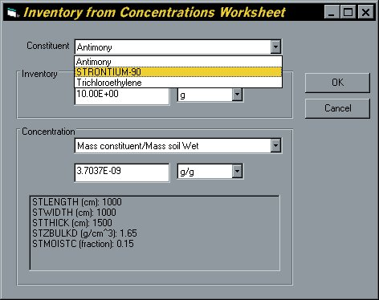

Figure 3.1.3 Constituent inventory worksheet

3.1a Adding References

The user can insert references to the User Input data. Click on the parameter you would like to reference and then select the Reference menu located on the tool bar (Figure 3.1.4).
Figure 3.1.4 Adding References to User Input
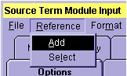
The menu shows two choices 'Add' or 'Select'. Choose 'Add' and type in the information on the open Reference screen. The first time a reference is added, a message will appear “No reference file found! Creating new file.” Select ‘Ok’ and the reference add feature will open.

Each reference is assigned a number, which will be shown to the right of the value (Figure 3.1.5). Once a reference has been entered, the same reference can be used for other parameters in this and other modules. Click on a parameter to select the same reference and choose 'Select' from the menu in Figure 3.1.4. You can add more references at this time to the reference file by clicking on the '<<' or '>>' keys and typing in references on the screen labeled Short Description of Reference 0. Or use the '<<' and '>>' keys to find the screen with the reference related to the parameter you clicked on to open the screen. If you have many references in the file, type a word into the box labeled 'Search for:' located at the bottom of the References screen and click 'Find' the screen with the search word will be shown.
When the desired reference page is open, click 'Ok' to return to the User Input the screen. The reference by the parameter will now turn from 0 to the number of the reference. In Figure 3.1.5 the reference number is 1.
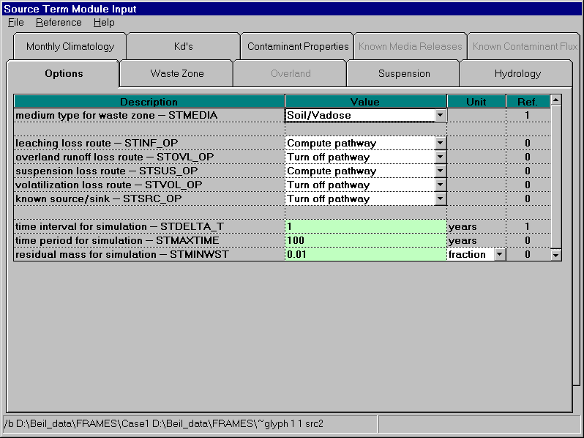
Figure 3.1.5 Values referenced on the User Input screen
There is one reference file for the whole scenario, so a reference can be entered in the Source Term Module and used in the same gid file for another module.

3.1b Running Modules

There are two different ways to run the module. Either run each model immediately following data entry or wait until all modules have yellow lights and run them with one click of the GO button located on the toolbar (Figure 3.1.6).

The GO button will run all the models in sequence without the user starting each run. If you choose to run each model separately, then right click on the Source Term icon and select ‘Run Model.’ Every model will run in a MS-DOS screen (Figure 3.1.7) before returning to the main FRAMES window. The icon will now have a green signal light.
Figure 3.1.6 Automatically run all modules
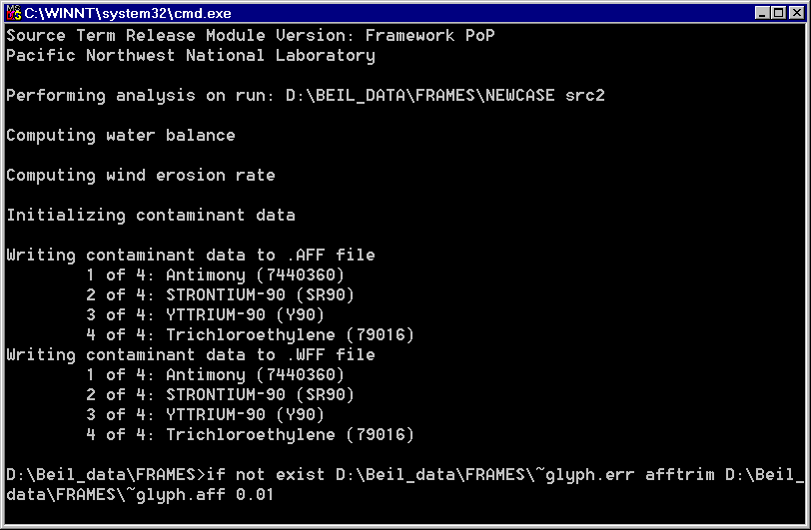
Figure 3.1.7 The model runs in a MS-DOS screen then returns to FRAMES
3.2 First Vadose Zone Module

The Vadose Zone Module simulates the movement of solutes through partially saturated porous media. Multiple Vadose Zone icons can be attached to the Source Term depicting the different medium layers (i.e., soil, clay, etc).

Follow the basic instructions outlined in Section 3.1 to enter the scenario specific data from Appendix 4.3. The module used for this example scenario is the MEPAS 4.1 Vadose Zone Module.

3.3 Second Vadose Zone Module

Follow the basic instructions outlined in Section 3.1 to enter the scenario specific data from Appendix 4.4. The module used for this example scenario is the MEPAS 4.1 Vadose Zone Module.

3.4 Saturated Zone Module

The Saturated Zone Module is also known as the Aquifer Module and simulates the movement of solutes through saturated porous media.

Follow the basic instructions outlined in Section 3.1 to enter the scenario specific data from Appendix 4.5. The module used for this example scenario is the MEPAS 4.1 Saturated Zone Module.

3.5 Surface Water Module

The Surface Water Module is also known as the River Module and simulates the movement of solutes through non-tidal rivers. Follow the basic instructions outlined in Section 3.1 to enter the scenario specific data from Appendix 4.7. The module used for this example scenario is the MEPAS 4.1 River Module.

3.6 Atmospheric Transport Module

Follow the basic instructions outlined in Section 3.1 to enter the scenario specific data from Appendix 4.6. The module used for this example scenario is the MEPAS 4.1 Air Module. The Joint Frequency Data tab of the User Input section contains an option called 'Import Joint Frequency Data.' Use this option to import data to fill the wind class tabs instead of typing in the information. All of the classes must have a number entered on the Joint Frequency Data tab before continuing. For more detailed information on importing joint frequency data, contact the software developers.

3.7 Exposure Pathways Module

Follow the basic instructions outlined in Section 3.1 to enter the scenario specific data from Appendix 4.8. The module used for this example scenario is the MEPAS 4.1 Chronic Exposure Module.

3.8 Receptor Intake Module

Follow the basic instructions outlined in Section 3.1 to enter the scenario specific data from Appendix 4.9. The module used for this example scenario is the MEPAS 4.1 Intake Module.

3.9 Human Health Impact Module

Follow the basic instructions outlined in Section 3.1 to enter the scenario specific data from Appendix 4.10. The module used for this example scenario is the MEPAS 4.1 Human Health Impact Module.

3.10 Selecting a Viewer

To view results, the signal light on the module must be green signaling the run completed. Follow the instructions under the modules above to run the modules before proceeding if the signal lights are not green. Right click on the module for which a viewer is desired and select ‘View/Print Module Output’ from the pop-up menu (Figure 2.4.1). Select the desired viewer from the View/Print Module Output list. There are at least two choices for each viewer attached to a module: a graphical and text viewer. To see the results in the various viewers, reselect a different viewer.

3.11 Customizing The Workspace

The font, background and linkages can all be customized. To customize the screen, click on the ‘Customize’ menu located on the top menu bar.
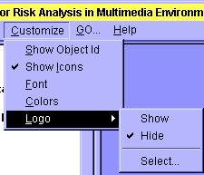
Click on Font to customize the font, style and size. Colors allows for customization of Database Connection, Model Connection, System Connection, and the workspace. Click on the item on the left side of the screen shown in Figure 3.11.2, then click on the foreground and background color to change. The Visible box should be checked as the default, but may be unchecked if so desired.
Figure 3.11.1 Customize menu

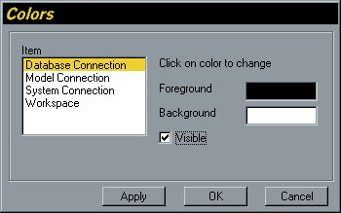
In the upper left corner of the FRAMES screen, above the Icon toolbar, an optional logo can be shown. Click the Customize menu from the menu bar and select Logo > Select. The file selection menu will open with all picture files shown (i.e., *.jpg, *.bmp, *.ico). Select one of the pictures from the list in the default FRAMES folder, or use a user created picture file. Click Open and the new logo will be displayed. To hide the logo, select Logo > Hide.
Figure 3.11.2 Colors Customize menu

3.12 Printing The Scenario

Now that the scenario is complete, the components can be printed to file or printer for documentation. Click on the File menu from the menu bar and select Print. The Print form will display all modules for all scenarios and checkboxes for the user to select which components to print. Click the Preview checkbox to see what will be printed before actually doing so. As you change selections, the contents of the preview panel will change. Click Print to select a Printer and set print options. Click Print again to print the document. If you have checked Print to File you will be prompted to select or name the output file; click Open to confirm or Cancel. Confirm the Print to File by opening the output file with a word processor to verify the contents. Click Close to return to the FRAMES screen.

4.0 Appendix
This appendix contains all the data needed for running the example scenario described in Getting Started.

4.1 Constituent Database Module
General Info
Label: Constituents
Applicable Module: FRAMES Default Chemical Database Selection
User Input
Select from All Possible Constituents:
Antimony
STRONTIUM-90
Trichloroethylene

4.2 Source Module
General Info
Label: Source
Applicable Model: MEPAS 4.1 Computed Source Term Release Module

User Input

Options
Medium type for waste zone - STMEDIA | soil/vadose
Leaching loss route– STINF _ OP | Compute Pathway
Overland runoff loss route– STOVL _ OP | Turn off pathway
Suspension loss route– STSUS _ OP | Compute Pathway
Volatilization loss route– STVOL _ OP | Turn off pathway
Known Source/Sink – STSRC _ OP | Turn off pathway
Time interval for simulation – STDELTA _ T | 1 | years
Time period for simulation – STMAXTIME | 100 | years
Residual mass for simulation - STMINWST | 0.01 | fraction

Waste Zone
Thickness of clean overburden- STCLEAN | 0.0 | m
Thickness– STTHICK | 15.0 | m
Length - STLENGTH | 10.0 | m
Width - STWIDTH | 10.0 | m
Bulk density – STZBULKD | 1.65 | g/cm^3
Total porosity – STTOTPOR | 30 | %
Moisture content – STMOISTC | 15.0 | %
Volumetric air content – STAIRSPC | 0.15 | fraction
Average air temperature - STAVTEMP | 53.006 | F
Height above ground of local wind measure - STWINDHT | 10 | m
Mean annual wind speed – STAVWINDV | 7.99928 | mi./hr

Suspension
Dry bulk density of surface soil - STSBULKD | 1.65 | g/cm^3
Sand in the surface soil – STSAND | 15 | %
Fraction of surface cover - STCORRSC | 0%<=x<=1%
Surface roughness length – STLOCSUR | 1.0 | Cm
Surface area covered with vegetation - STVEGFR | 0 | fraction
Surface area covered with a crust layer – STCRUST | 0 | fraction
Number of mechanical disturbances to site | 1 | #/month
Maximum wind speed at site – STMAXWIND | 79.99954 | mi./hr.
Thornwaite’s Precipitation – Evaporation index - STPEI | 25
Is there roadway travel at the site – STROADS | None
Paved roadway
Distance of roadway traveled – STRTDIST |  | km
Average speed of vehicles per trip – STVSPEED |  | km/hr
Average weight of vehicles – STVWEIGH |  | Ton
Number of round-trips per month – STRTNUM |  | #/day
Percent of silt on road surface - STSILT |  | %
Average number of vehicle wheels - STWHEELS |  | #
Unpaved Roadways
Distance of roadway traveled – STRTDIST |  | km

Hydrology
Elevation of LCD station – STLCDELEV | 223 | m
Latitude of waste site – STLAT | 46.57 | degrees
Elevation of waste site – STELEV | 223 | m
SCS curve number - STSCSCN | 39
Top soil water capacity – STAVAILW | 1.1 | cm
# of days with >0.254mm precipitation – STNUMPRCP | 68

Monthly Climatology
Param | Temp | Percip | Windsp | Cloudy | Precip Days | Min humid | Max humid
Unit | F | In | Mi/hr | Fraction | days | % | %
 | sttemp | stmprecip | stwindv | stcloud | stmnumpre | strhmin | strhmax
January | 30.002 | 1.0 | 6.39987 | 0.79 | 9 | 65 | 82
February | 37.9994 | 1.0 | 7.10003 | 0.76 | 7 | 58 | 80
March | 44.0006 | 1.5 | 8.50036 | 0.68 | 6 | 40 | 70
April | 51.9998 | 1.5 | 8.99919 | 0.64 | 5 | 32 | 70
May | 60.9998 | 1.25 | 8.90077 | 0.59 | 5 | 30 | 70
June | 69.0008 | 1.1 | 9.20052 | 0.53 | 5 | 25 | 70
July | 77.0 | 1.0 | 8.69944 | 0.29 | 2 | 20 | 70
August | 75.0002 | 0.9 | 7.99928 | 0.34 | 3 | 20 | 75
September | 66.0002 | 0.8 | 7.50045 | 0.41 | 3 | 25 | 80
October | 53.0006 | 0.9 | 6.59896 | 0.58 | 5 | 25 | 80
November | 39.9992 | 0.9 | 6.10012 | 0.77 | 8 | 30 | 85
December | 33.0008 | 1.0 | 6.10012 | 0.81 | 10 | 30 | 85

K_{d}’s
Equilibrium coefficient KD– STKD |  | Ml/g
Antimony | 2 | 0.0 | 0
 |  | 0.0 | 100
STRONYIUM-90 | 2 | 2.4 | 0
 |  | 2.4 | 100
Trichloroethylene | 2 | 0.76 | 0
 |  | 0.76 | 100
*YTTRIUM | 2 | 228.0 | 0
 |  | 228.0 | 100

Constituent Properties
Water solubility-STSOL
Antimony |  | 1.0E+06 | mg/L
STRONTIUM -90 |  | 1.0E+06 | mg/L
Trichloroethylene |  | 1100.0 | mg/L
*YTTRIUM -90 |  | 1.0E+06 | mg/L
Constituent inventory quantity-STINVEN
Antimony | Worksheet¹ | 10.0 | G
STRONTIUM-90 | Worksheet¹ | 10.0 | Ci
Trichloroethylene | Worksheet¹ | 10.0 | g
Decay/degradation half life-STGHALF
Antimony |  | 0.0 | Day
STRONTIUM -90 |  | 10600.0 | Day
Trichloroethylene |  | 0.0 | Day
*YTTRIUM -90 |  | 2.7 | Day
Fraction of volatilization release-STVOLRAT
Antimony |  | 0.0 | Fraction
STRONTIUM-90 |  | 0.0 | Fraction
Trichloroethylene |  | 0.0 | Fraction
¹ Click on this parameter and enter 10 for the inventory of each contaminant.

4.3 Vadose Zone Transport Module
General Info
Label: Vadoze_1
Applicable Model: MEPAS 4.1 Vadose Zone Module
User Input

Soil Composition
Soil Class – WP-CLASS | Sand
Percentage of sand – WP-SAND | 92.0 | %
Percentage of silt – WP-SILT | 5.0 | %
Percentage of clay – WP-CLAY | 3.0 | %
Percentage of organic matter – WP-OMC | 0.0 | %
Percentage of iron and aluminum – WP-IRON | 0.0 | %
Soil type coefficient – WP-SOILCOEF | 4.05

Characteristics
pH of the pore water – WP-PH | 7.0 | pH
Total porosity – WP-TOTPOR | 38.0 | %
Field capacity – WP-FIELDC | 9.0 | %
Hydraulic conductivity – WP-CONDUC | 570.24 | cm/day
Thickness of this layer – WP-THICK | 7.0 | Ft
Longitudinal dispersivity – WP-LDISP | 0.07 | Ft
Dry bulk density – WP-BULKD | 1.64 | g/cm^3

Constituent Parameters
Adsorption coefficient – WA-SUBKD
Antimony | 2 | ml/g
 | 2 | ml/g
STRONTIUM-90 | 24.3 | ml/g
 | 24.3 | ml/g
*YTTRIUM-90 | 228 | ml/g
 | 228 | ml/g
Trichloroethylene | 0.1066 | ml/g
 | 0.106596 | ml/g
Water Solubility – WP-SOL
Antimony | 1E + 23 | mg/L
STRONTIUM-90 | 1E + 23 | PCi/ml
*YTTRIUM-90 | 1E + 23 | PCi/ml
Trichloroethylene | 1100 | mg/L
Half-life in ground water – WP-GHALF
Antimony | 2.738E+17 | Day
STRONTIUM-90 | 10600 | Day
*YTTRIUM-90 | 2.7 | Day
Trichloroethylene | 2.738E+17 | Day

4.4 Vadose Zone Transport Module
General Info
Label: Vadoze_2
Applicable Model: MEPAS 4.1 Vadose Zone Module

User Input

Soil Composition
Soil Class – WP-CLASS | Sand
Percentage of sand – WP-SAND | 91.2 | %
Percentage of silt – WP-SILT | 6.3 | %
Percentage of clay – WP-CLAY | 2.5 | %
Percentage of organic matter – WP-OMC | 0.0 | %
Percentage of iron and aluminum – WP-IRON | 0.0 | %
Soil type coefficient – WP-SOILCOEF | 4.0

Characteristics
Ph of the pore water – WP-PH | 8.5 | pH
Total porosity – WP-TOTPOR | 38.0 | %
Field capacity – WP-FIELDC | 9.0 | %
Hydraulic conductivity – WP-CONDUC | 570.24 | cm/day
Thickness of this layer – WP-THICK | 15.2 | Cm
Longitudinal dispersivity – WP-LDISP | 0.0 | Cm
Dry bulk density – WP-BULKD | 1.64 | g/cm^3

Constituent Parameters
Adsorption coefficient – WA-SUBKD
Antimony | 2 | ml/g
 | 2 | ml/g
STRONTIUM-90 | 24.3 | ml/g
 | 24.3 | ml/g
*YTTRIUM-90 | 228 | ml/g
 | 228 | ml/g
Trichloroethylene | 0.1005 | ml/g
 | 0.1004976 | ml/g
Water Solubility – WP-SOL
Antimony | 1E + 23 | mg/L
STRONTIUM-90 | 1E + 23 | PCi/ml
*YTTRIUM-90 | 1E + 23 | PCi/ml
Trichloroethylene | 1100 | mg/L
Half-life in ground water – WP-GHALF
Antimony | 2.738E +17 | Day
STRONTIUM-90 | 10600 | Day
*YTTRIUM-90 | 2.7 | Day
Trichloroethylene | 2.738E +17 | Day

4.5 Ground Water Transport Module
General Info
Label: Aquifer
Applicable Model: MEPAS 4.1 Saturated Zone Module

User Input

Soil Composition
Soil Class – WZ-CLASS | Loam
Percentage of sand – WZ-SAND | 65.0 | %
Percentage of silt – WZ-SILT | 25.0 | %
Percentage of clay – WZ-CLAY | 10.0 | %
Percentage of organic matter – WZ-OMC | 0.0 | %
Percentage of iron and aluminum – WZ-IRON | 0.0 | %

Characteristics
Percentage constituent flux entering aquifer – WZ-FRACT | 100.0 | %
pH of the pore water – WZ-PH | 7.0 | pH
Total porosity – WZ-TOTPOR | 46 | %
Effective porosity – WZ-EFFPOR | 20.0 | %
Darcy velocity – WZ-PVELOC | 0.01 | ft/day
Thickness of aquifer – WZ-THICK | 40.0 | ft
Dry bulk density – WZ-BULKD | 1.43 | g/cm^3

Concentration Locations
Usage location Groundwater_Well (exp8)
Longitudinal Distance to well– WZ-DIST | 100.0 | M
Perpendicular distance from plume center line to well-- WZ-YDIST
Vertical distance below water table to well intake-- WZ-AQDEPTH
Longitudinal dispersivity – WZ-LDISP | 10.0 | M
Transverse dispersivity – WZ-TDISP | 3.3 | M
Vertical dispersivity – WZ-VDISP | 0.025 | M

Flux Locations
Usage location Surface_Water (riv10)
Longitudinal distance to flux location– WZ-DIST | 100.0 | M
Longitudinal dispersivity – WZ-LDISP | 10.0 | M
Transverse dispersivity – WZ-TDISP | 3.3 | M
Vertical dispersivity – WZ-VDISP | 0.025 | M

Constituent Parameters
Antimony | 6 | ml/g
 | 6 | ml/g
STRONTIUM-90 | 100 | ml/g
 | 100 | ml/g
*YTTRIUM-90 | 538 | ml/g
 | 538 | ml/g
Trichloroethylene | 0.382 | ml/g
 | 0. 382095 | ml/g
Water Solubility – WZ-SOL
Antimony | 1E + 23 | mg/L
STRONTIUM-90 | 1E + 23 | PCi/ml
*YTTRIUM-90 | 1E + 23 | PCi/ml
Trichloroethylene | 1100 | mg/L
Half-life in ground water – WZ-GHALF
Antimony | 2.738E + 17 | day
STRONTIUM-90 | 10600 | day
*YTTRIUM-90 | 2.7 | day
Trichloroethylene | 2.738E + 17 | day

4.6 Atmospheric Transport Module
General Info
Label: Air
Applicable Model: MEPAS 4.1 Air Module

User Input

Climatology
Reference weather station (AC-LCDREF) | Hanford Met Station
Morning mixing height (AC-MIXAM) | 400.0 | M
Afternoon mixing height (AC-MIXPM) | 1400.0 | M
Annual precipitation (AC-RAIN) | 6.3 | in
Precipitation days per year (AC-PRENUM) | 68
Thunderstorms per year (AC-NUMTS) | 10

Joint Frequency Data /General
Data Station (AJ-STATNM) | Hanford Met Station
Anemonometer height (AJ-ANEMHT) | 15.2 | M
Average roughness length (AJ-RLEN) | 45.5 | Cm
Wind Speed midpoints (AJ-WINDS) | 0.671 | m/s
 | 2.46 | m/s
 | 4.48 | m/s
 | 6.94 | m/s
 | 9.62 | m/s
 | 12.53 | m/s
Wind joint frequency Calms (AJ-CALMS) | 0.000 | Number
 | 0.000 | Number
 | 0.000 | Number
 | 0.000 | Number
 | 0.000 | Number
 | 0.000 | Number
 | 0.000 | Number
Import Joint Frequency Data*

* Find file ???.jfd in the FRAMES directory

Topographical Data/Surface Roughness
□ Use regional topographical data (AR-TOPTYP)
□ Use wind channel modeling (AR-CHANL)
Elevation of release unit (AR-TOPBAS)

Regional surface roughness (AR-REGSUR) = all 10Cm

4.7 Surface Water Transport Module
General Info
Label: Surface Water

Applicable Module: MEPAS 4.1 River Module

User Input
Flow Velocity at contaminant entry point– WW-VELOC | 10.0 | mi./yr.
Depth at contaminant entry point – WW-DEPTH | 10.0 | Ft
Width at contaminant entry point – WW-WIDTH | 100.0 | Ft
Usage Location | Ground Water Well (fcm5)
Distance from source to location – WW-DIST | 100.0 | Ft
Average annual discharge at location – WW-DISCHG | 10000.0 | cm^3/s

4.8 Exposure Pathway Module
General Info
Label: Groundwater_Well
Applicable Model: MEPAS 4.1 Chronic Exposure Module

User Input

Ground Water/ Pathways
Exposure duration – EG-DGWED | 35.0 | Yr.
Plant Product Ingestion   Leafy vegetables   Other vegetables  Animal Product Ingestion   Meat   Milk | Other Ingestion   Drinking water   Shower water  Inhalation   Air-Volatiles from water  ○ Shower-Air   Indoor-Air | Dermal   Shower

Ground Water/ Water Usage
◻ Animal Drinking
 Irrigation of animal feed
Fraction of the year that surface water is used for irrigation –EG-FIRR | 1.0
Irrigation rate - EG-CIRR | 100.0 | L/m^2/m
Domestic water distribution time – EG-TWTR | 0.5 | Day
◻ Domestic water is treated – EG-LTRTL

Surface Water/ Pathways
Exposure duration – EW-DSWED | 35.0 | Yr.
Plant Product Ingestion   Leafy vegetables   Other vegetables  Animal Product Ingestion   Meat   Milk   Finned Fish   Shell Fish | Other Ingestion   Drinking water   Shower water   Swimming water   Shoreline sediment  Inhalation   Air-Volatiles from water  ○ Shower-Air   Indoor-Air | Dermal   Shower  □ Swimming  ◻ Shoreline  External   Swimming   Shoreline   Boating

Surface Water/Water Usage
 Animal Drinking
 Irrigation of animal feed
Fraction of the year that surface water  is used for irrigation –EW-FIRR | 1.0
Irrigation rate - EW-CIRR | 100.0 | L/m^2/m
Domestic water distribution time – EW-TWTR | 0.5 | Day
◻ Domestic water is treated – EW-LTRTL

Surface Water/ Recreational
Finfish ingestion harvest delay time-EW-TFISH | 10.0 | Day
Shellfish ingestion harvest delay time-EW-TINV | 10.0 | Day
Thickness of shoreline sediments-EW-TSS | 0.04 | M
Density of shoreline sediments-EW-RHOSS | 1.5 | G/cm^3
Finfish fillet correction factor-EW-TISSUE

Atmospheric/ Pathways
Exposure duration-EA-ATED | 35.0 yr
Plant Product Ingestion   Leafy vegetables   Other vegetables  Animal Product Ingestion   Meat   Milk | Other Pathways   Soil-Ingestion   Soil-Inhalation   Soil-Dermal   Soil- External  □ Air- External   Air-Inhalation

Atmospheric/ Deposition
Thickness of soil receiving deposition – EA-TAS | 0.04 | M
Density of soil receiving deposition – EA-RHOAS | 1.5 | g/cm^3

Exposure Controls
Time to start exposure computation – EC-TEXPOS | 0.0 | Yr.
Maximum time for reporting – EC-MAXTIM | 100.0 | Yr.
Number of time points for evaluation – EC-NTIMES | 2.0

Leach Rates
Leach rate selection option – EC-LEACHOPTION | User provided leach rate constants
Parent surface soil leach rate constant
Antimony | 1.0 | 1/yr.
STRONTIUM-90 | 1.0 | 1/yr
Trichloroethylene | 1.0 | 1/yr
Progeny surface soil leach rate constant
YTTRIUM-90 | 1.0 | 1/yr.

4.9 Receptor Intake Module
General Info
Label Receptor_Intake
Applicable Models: MEPAS 4.1 Intake Module
User Input
Body weight of individual –IC-BODYWT | 70.0 | Kg.
Exposure duration - IC-EXPDUR | 30.0 | Yr.
Water dermal absorbtion model-IC-DERM |  | EPA Model
Ground water ingestion rate – IG-UDWGW | 2.0 |  | L/d
Surface water ingestion rate – IW-UDWSW | 2.0 |  | L/d
Age of receptor at start of exposure – IC-TAGE1 | 0.0 |  | Yr.
Age of receptor at end of exposure – IC-TAGE2 | 70.0 |  | Yr.
Note: Domestic use population (IG-POPGW) is assumed to be 1 in this MEPAS module.

4.10 Human Health Impact Module
General Info
Label: Health_Impacts
Applicable Model: MEPAS 4.1 Human Health Impact Module

User Input

Chemical
 Calculate lifetime cancer incidence – CHEMRISK
 Calculate hazard index – CHEMH
0.0
Hazard quotient threshold limit – RFDLIM
Method for inhalation impact analysis -- INHALE | Air Concentration

Radionuclide
 Calculate lifetime cancer incidence – HE-INC  Conversion factor – HE-CONINC | 0.06 | Risk/Sv
 Calculate cancer fatalities – HE-FAT  Conversion factor – HE-CONFAT | 0.05 | Risk/Sv
 Calculate lifetime cancer & severe hereditary effects – HE-FSH  Conversion factor – HE-CONFSH | 0.073 | Risk/Sv
 Calculate radiation dose commitment (CEDE) – HE-CEDE
Cancer risk evaluation method – IHEAST | ICRP dose  and risk factors
Thickness of contaminated soil/sediment layer – TSOIL | 0.04 | M
Density of contaminated soil/sediment layer – DSOIL | 1.5 | g/cm^3

4.11 FRAMES File Extensions

AFF | Air Flux File
ATO | Atmospheric Transport Output File
BBF | Body Burden File
DES | Description File
EPF | Exposure Pathways File
EXF | Ecological Exposure File
ERR | Error File
GID | Global Input Data File
HIF | Health Impacts File
RIF | Receptor Intake File
SCF | Soil Concentration File
SUF | Sensitivity Uncertainty File
WCF | Water Concentration File
WFF | Water Flux File

